Assignment 3 : Retrieve data using Group By clause
1) Created Department Table
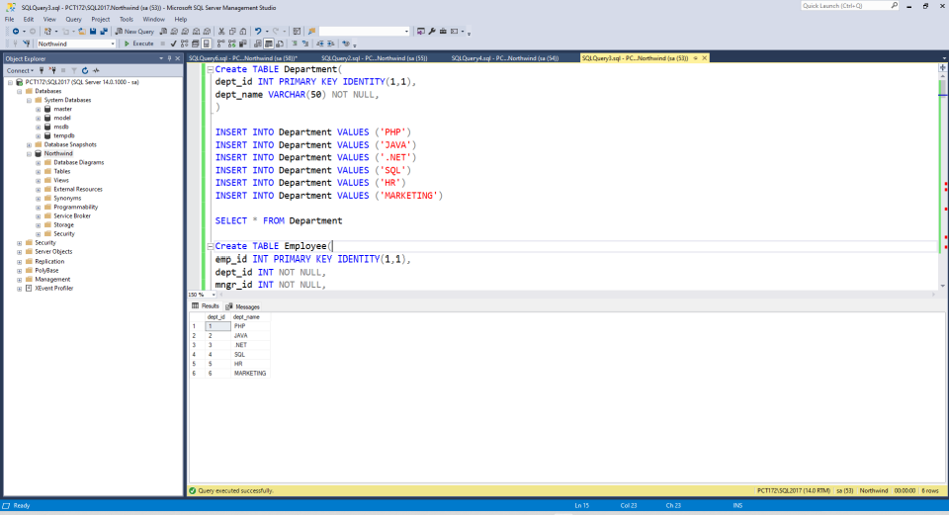
2) Created Employee Table
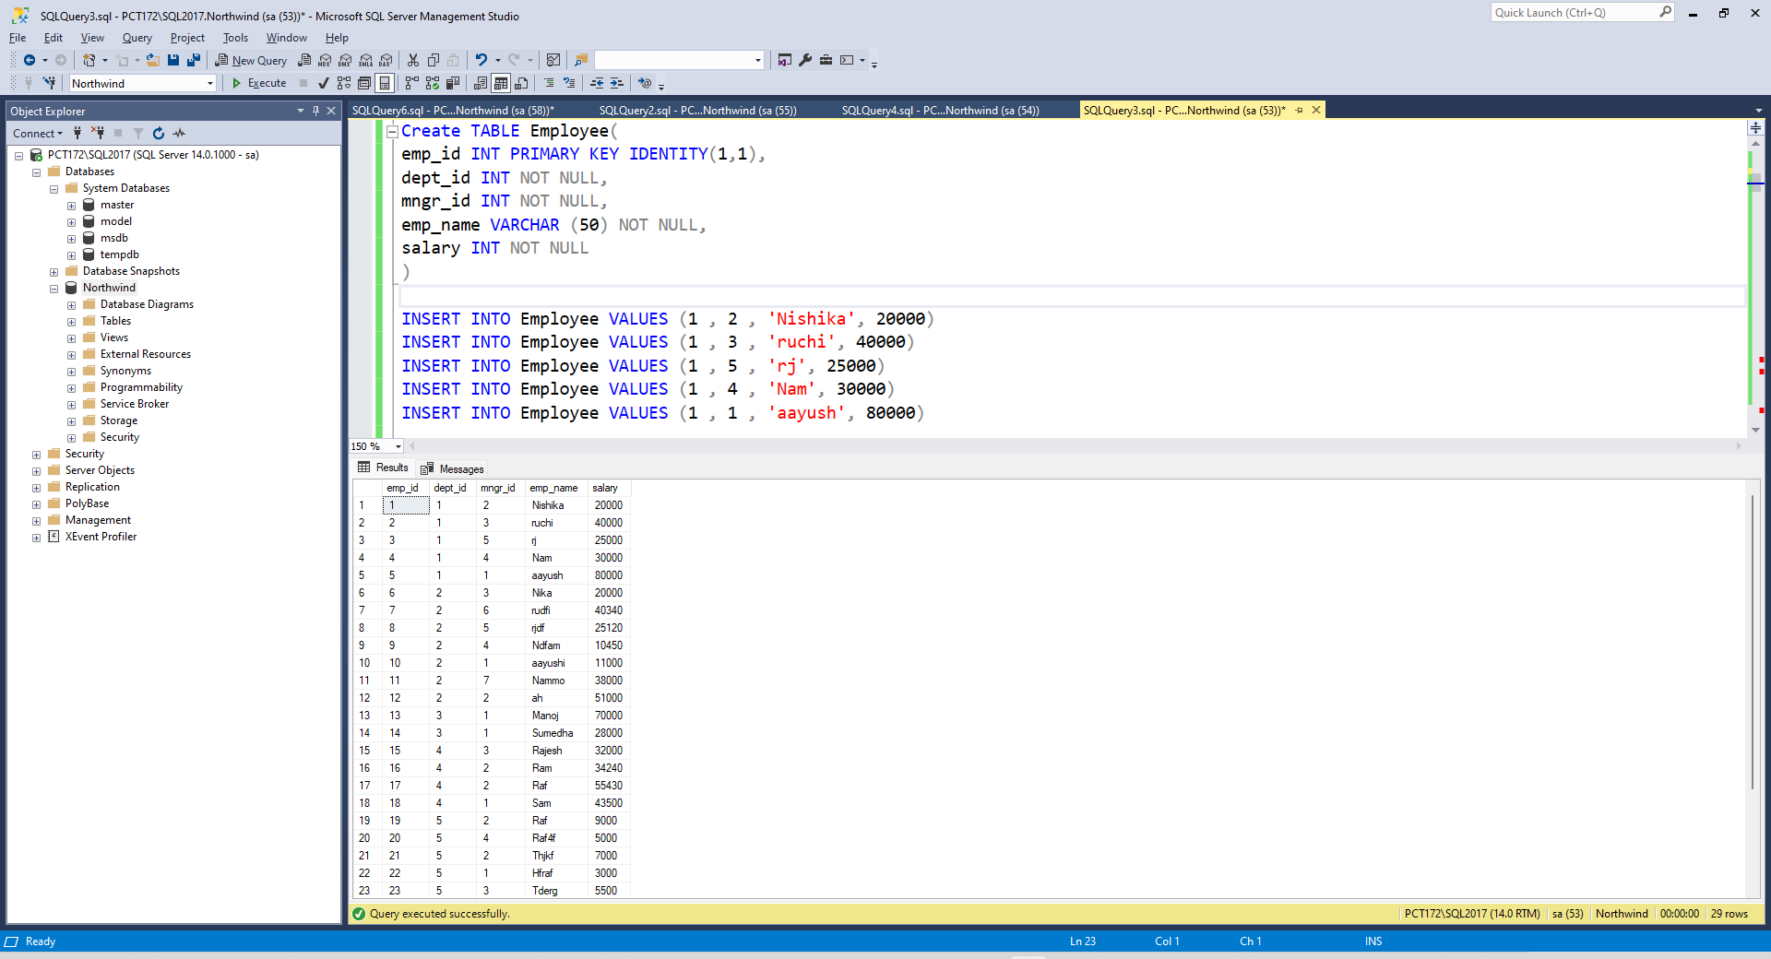

1. write a SQL query to find Employees who have the biggest salary in their Department

SELECT emp_name ,dept_name , salary
FROM Employee
JOIN Department
ON Department.dept_id = Employee.dept_id
WHERE salary IN
(SELECT MAX(salary) AS salary
From Employee
GROUP BY dept_id)

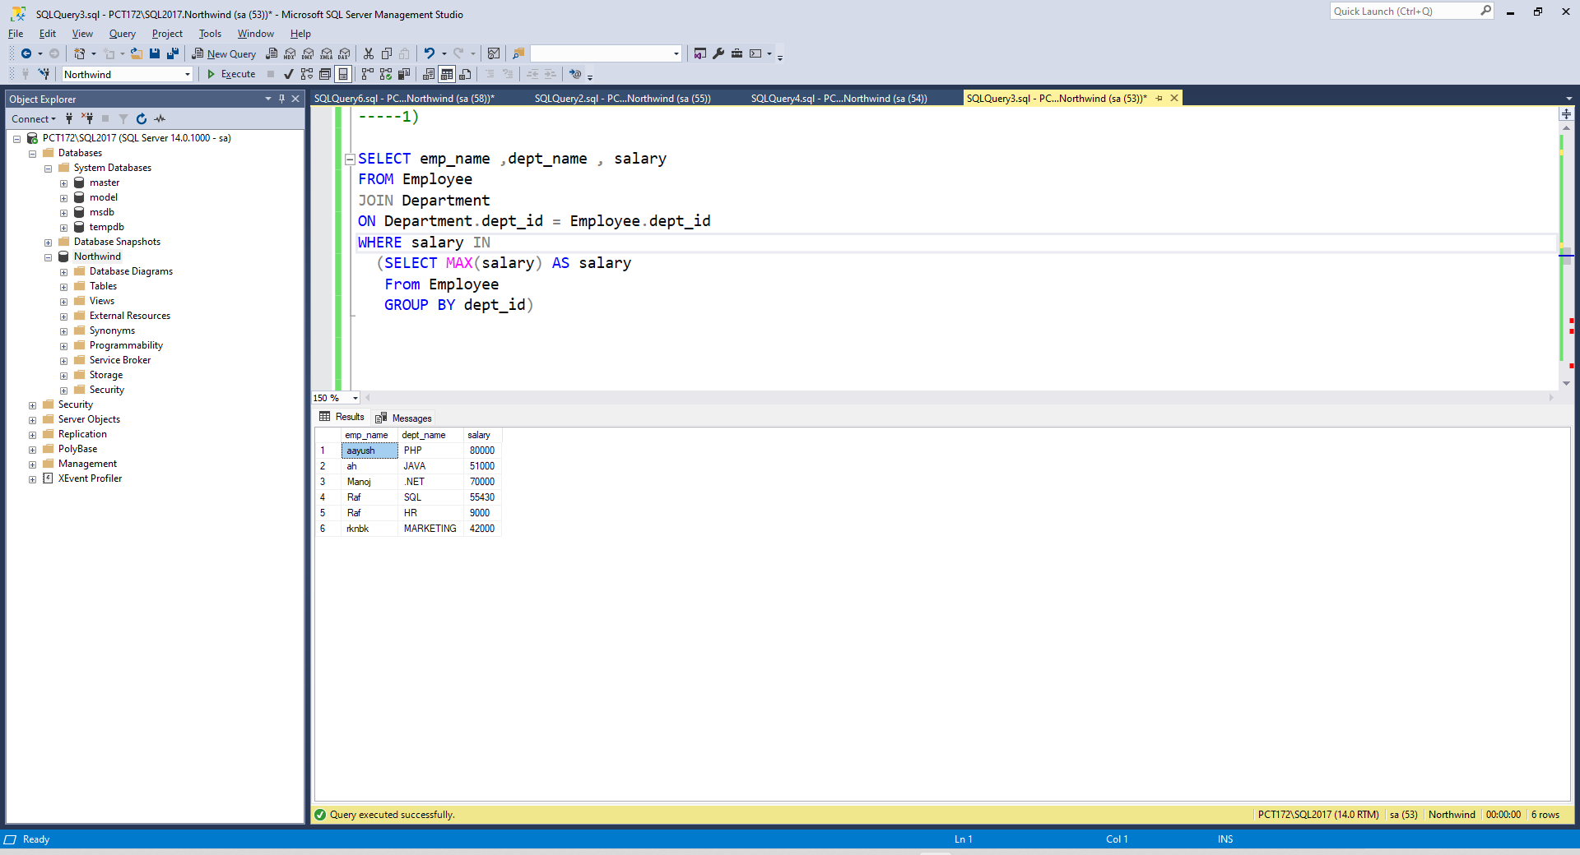

2. write a SQL query to find Departments that have less than 3 people in it.

SELECT dept_name , COUNT(emp_id) AS total_people
FROM Department
LEFT JOIN Employee
ON Department.dept_id = Employee.dept_id
GROUP BY dept_name
HAVING COUNT(emp_id) <3

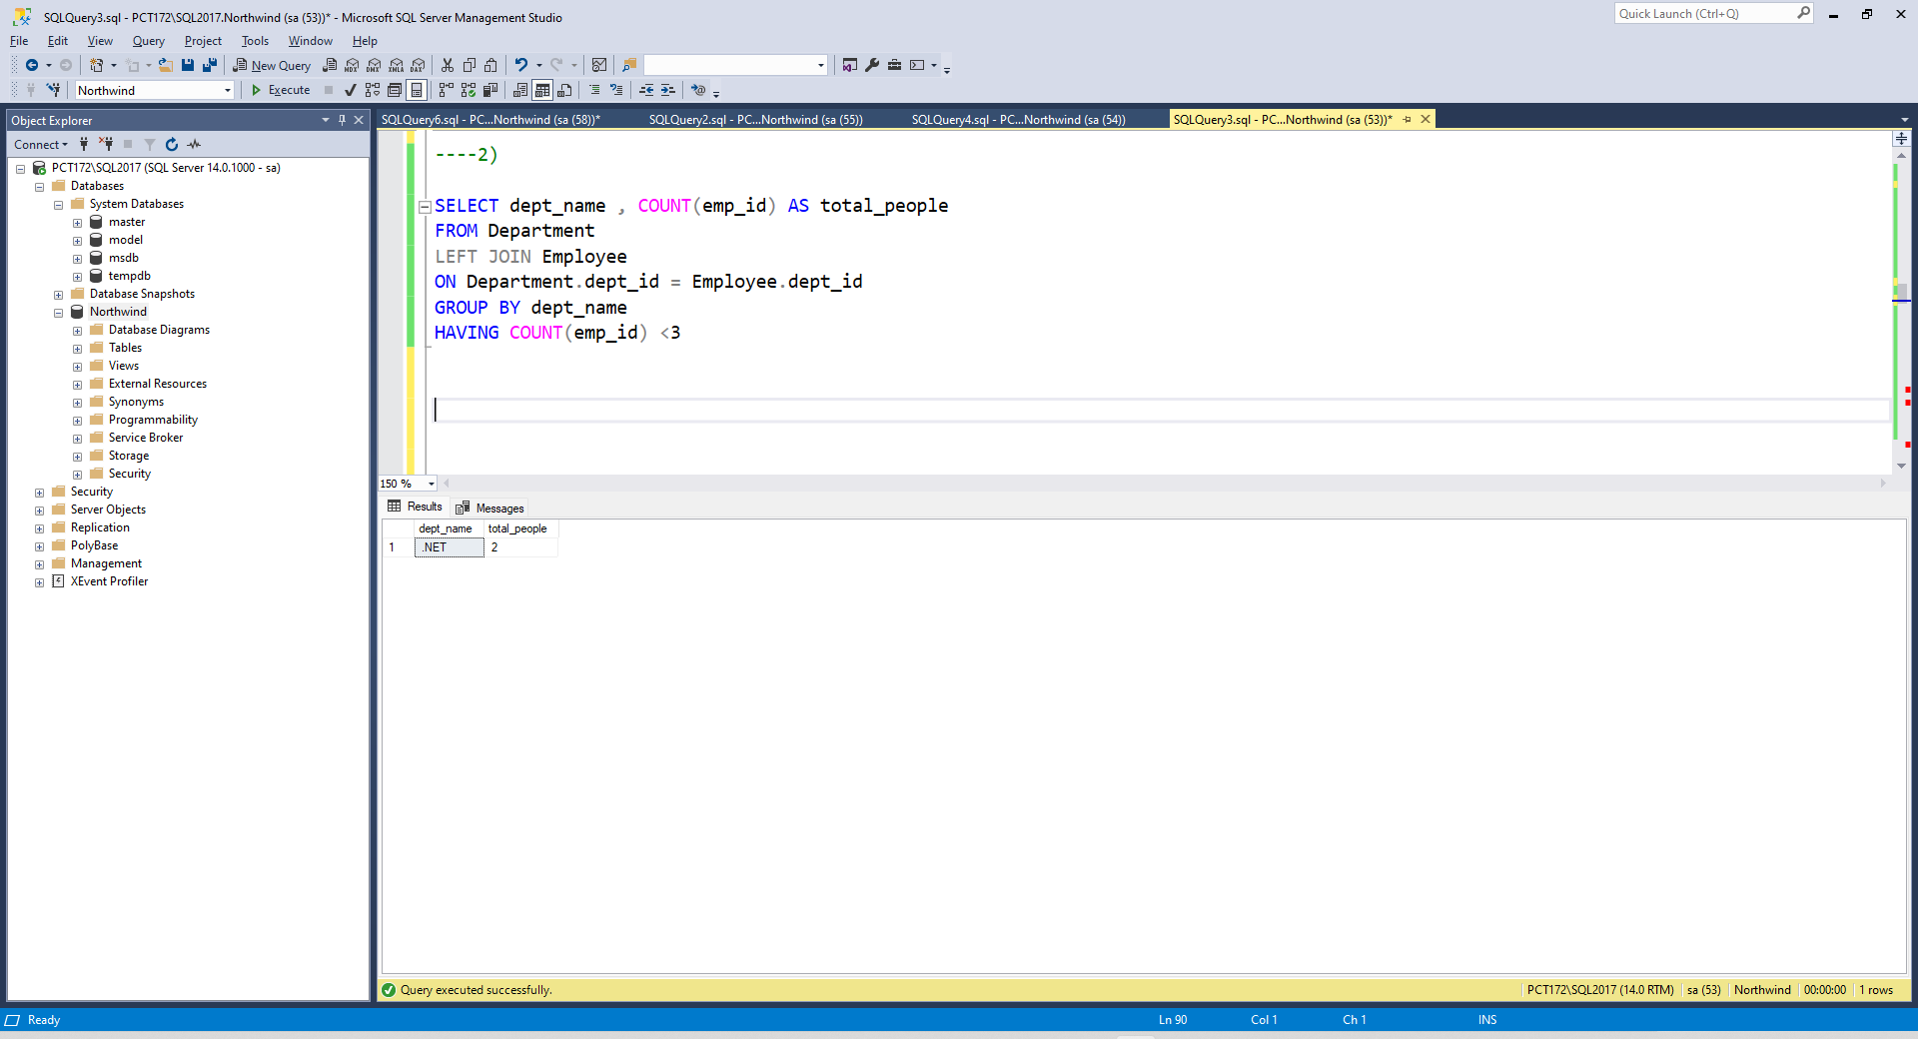

3. write a SQL query to find All Department along with the number of people there.

SELECT dept_name , COUNT(emp_id) AS total_people
FROM Department
LEFT JOIN Employee
ON Department.dept_id = Employee.dept_id
GROUP BY dept_name

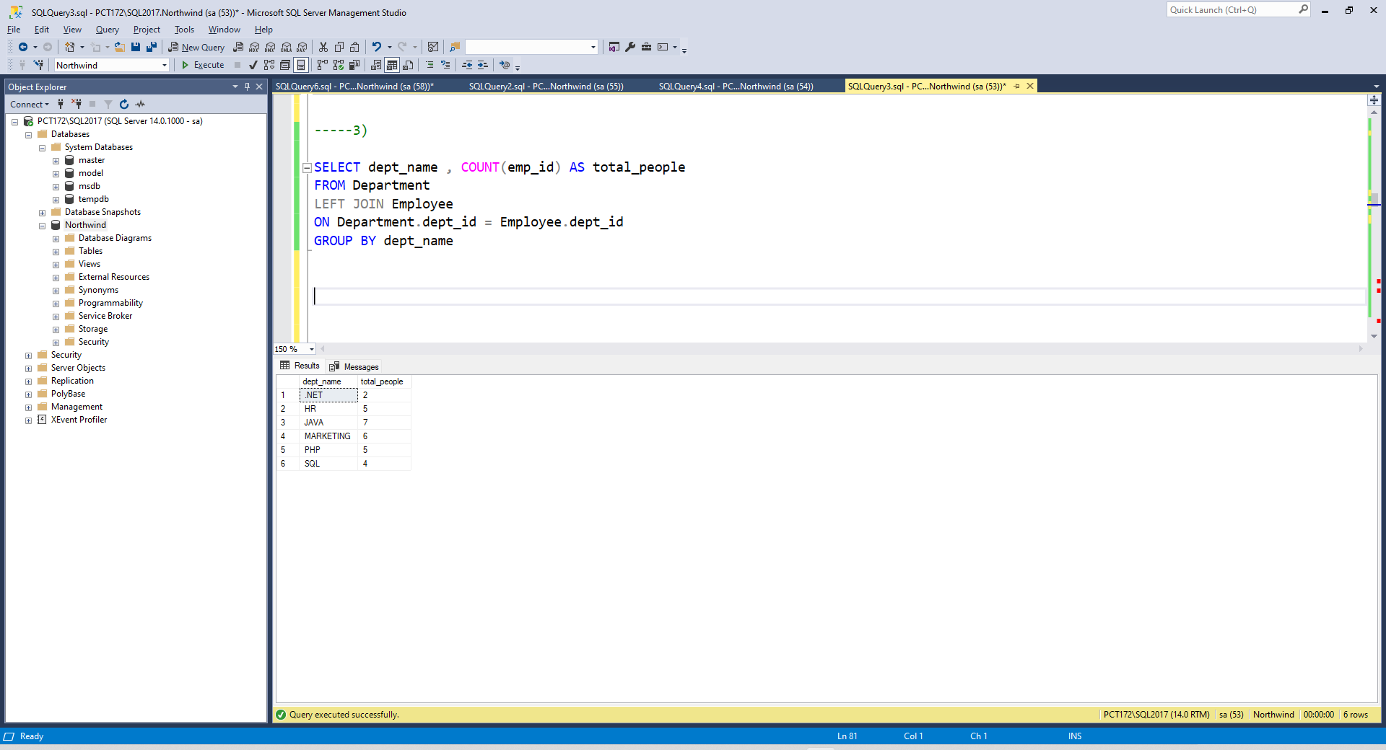

4. write a SQL query to find All Department along with the total salary there.

SELECT dept_name , SUM(salary) AS total_salary
FROM Department
LEFT JOIN Employee
ON Department.dept_id = Employee.dept_id
GROUP BY dept_name

